The Griots’ Circle of Maryland, Inc.
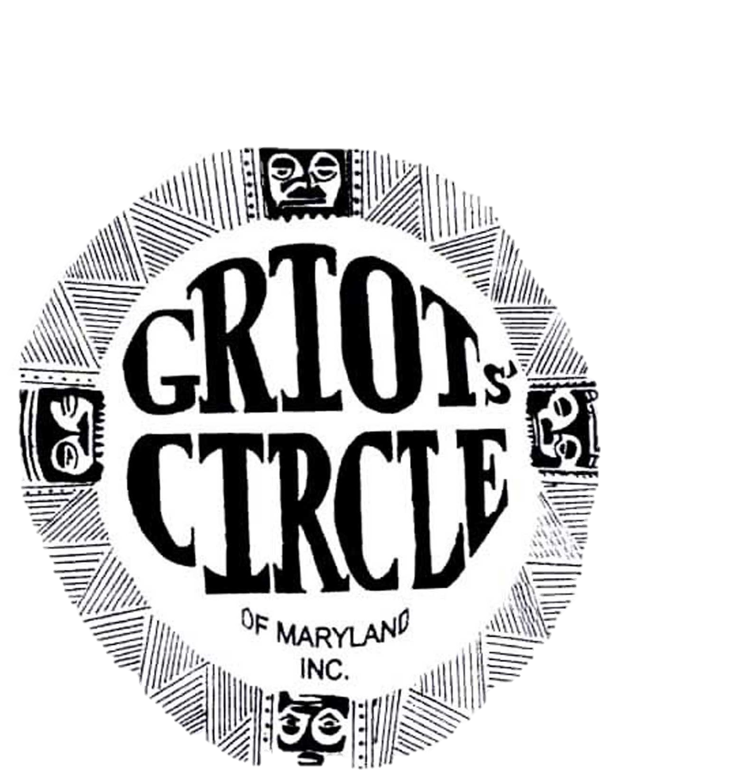
Annual Report
November 2022 - October 2023

We are proud of the previous officers and our festival committee members who provided leadership in carrying out our role in co-hosting the 40th NABS "In the Tradition . . ." National Black Storytelling Festival and Conference. We give thanks to our members who raised the funds for our donation to the festival expenses. They also helped with the Adopt-A-Teller community program, the Heritage Tour, the hotel arrangements, publicity, registration and the Pre-festival community program. It was great team work and we look forward to doing it again in 10 years.
In January 2023, the new officers were elected and we made plans to develop the storytelling skills of the membership. I am proud to report on the storytelling efforts of the Griots' Circle of Maryland during 2023. Some programs we participated in: Hampton Historic Site's Harvest Fest event, Love Stories our annual fundraiser, Black History program at National Great Blacks In Wax Museum. Some of our members were part of the founding of a Griot Organization in Western Maryland. We're giving a donation to Minnesota's Black Storytellers Alliance, a N.A.B.S. affiliate, in memory of Nothando Zulu.
The Griots' StoryBook is being sold at events and online. Several libraries have added the book to their collection and the title is included in the WorldCat database.
We are continuing to train young storytellers with our Growing Griots program. This year's sessions will concentrate on storytelling and will be a partnership with a local school's afterschool program. Our mentors will be working with the children and parents of Empowerment Temple Academy.
The library where the Griots' Circle's monthly meetings are held will be closed for renovation for several months. Until further notice, our meetings will be held at a different branch of Baltimore City's Pratt Library. All are welcome to attend our meetings which include storytelling activities. Our gatherings are available in person or virtually. Contact us by email for the in person location or for the zoom link. The email address is baltimoregriotcircle@hotmail.com. You can also check our webpage for updates and events. griotscircleofmarylandinc.org
Everyone is invited to come join the Circle! It will be a welcoming and fun experience.
Submitted By
John Carrington, President

November 2022 - Participation in the NABS 40th Festival and Conference
- Prefestival Program: A standing room audience enjoyed the program which brought to life some performers of Baltimore's historic Pennsylvania Ave entertainment district.
- Awards: Janice Curtis Greene – Zora Neale Huston Award
Tom "Gene" Curtis and William "Bill" Starke – Brother Blue Circle of Elders
Charles E. Brown II - Nia Award for Service

December 2022 – Members shared reflections of the NABS festival and their Kwanzaa plans.

January 2023 –Officers were installed and Fellisco Keeling received the Mary Carter Smith Legacy Award

February 2023 – Bunjo Butler shared a powerful life story of his journey to a career in librarianship.

March 2023 – Some members performed for the Women's History program at Manifest Wonder Church

April 2023 - We mourned the transition of our member Janet Jones long time Growing Griots supporter.

May 2023 – Members performed at 2 events in Hagerstown Maryland; the first meeting of the Black - Storytellers of Western Maryland and Stories in the Round program

June 2023 – A Juneteenth program stories and poetry and was directed by Grandmother Edna Williams
- At our monthly meeting, Margaret Powell shared her poetry and stories about her life.

July 2023 – Some members attended the Wilmington, Delaware Black Storytelling Residency
- Our monthly meeting was on hiatus; members performed at recreation centers and libraries.

August 2023 – We were blessed to have Mama Linda Goss share with us her birthday memories.

September 2023- Growing Griots is now an afterschool program at Empowerment Temple Academy.

October 2023 - Award announced:- Bob Smith To be inducted into Brother Blue Circle of Elders

October 15, 2023 - Love Stories Program; Theme: Love That Love Talk
